**STOCK MARKET AI CHATBOT**

MINOR PROJECT REPORT

By

ANJANY KUMAR JAISWAL(RA2311026010006)

**SACHIN PRASANTH (RA2311026010018)**

Under the guidance of   
**DR. VIJAYALAKSHMI KALIYAPERUM***In partial fulfilment for the Course*

of

**21CSS101J– PROGRAMMING FOR PROBLEM SOLVING**

in COMPUTER SCIENCE AND ENGINEERING WITH ARTIFICAL INTELLIGENCE AND MACHINE LEARNING



**FACULTY OF ENGINEERING AND TECHNOLOGY**

**SCHOOL OF COMPUTING**

**SRM INSTITUTE OF SCIENCE AND TECHNOLOGY**

**KATTANKULATHUR**

**NOVEMBER 2023**

**SRM INSTITUTE OF SCIENCE AND TECHNOLOGY**

**(Under Section 3 of UGC Act, 1956)**

**BONAFIDE CERTIFICATE**

Certified that this minor project report for the course **21CSS101J** **PROGRAMMING FOR PROBLEM SOLVING** entitled in "**STOCK MARKET AI CHATBOT**" is the bonafide work of **Anjany Kumar Jaiswal(RA2311026010006)** and **Sachin Prasanth(RA2311026010018)** who carried out the work under my supervision.

# SIGNATURE

Dr. Vijayalakshmi Kaliyaperum

# <Designation>

# Computational Intelligence

SRM Institute of Science and Technology

Kattankulathur

# ACKNOWLEDGEMENT

We express our heartfelt thanks to our honorable **Vice Chancellor Dr. C. MUTHAMIZHCHELVAN**, for being the beacon in all our endeavors.

We would like to express my warmth of gratitude to our **Registrar Dr. S. Ponnusamy,** for his encouragement.

We express our profound gratitude to our **Dean (College of Engineering and Technology) Dr. T. V.Gopal,** for bringing out novelty in all executions.

We would like to express my heartfelt thanks to Chairperson, School of Computing **Dr. Revathi Venkataraman,** for imparting confidence to complete my course project

We wish to express my sincere thanks to **Course Audit Professors Dr. Vadivu. G , Professor, Department of Data Science and Business Systems and Dr. Sasikala. E Professor, Department of Data Science and Business Systems** and **Course Coordinators** for their constant encouragement and support.

We are highly thankful to our my Course project Faculty **Dr. Vijayalkshmi** Kaliyaperum **, Computational Intelligence** for his/herassistance, timely suggestion and guidance throughout the duration of this course project.

We extend my gratitude to our **HoD Dr. R Annie Uthra, Computational Intelligence** and my Departmental colleagues for their Support.

Finally, we thank our parents and friends near and dear ones who directly and indirectly contributed to the successful completion of our project. Above all, I thank the almighty for showering his blessings on me to complete my Course project.

**TABLE OF CONTENTS**

|  |  |  |  |
| --- | --- | --- | --- |
| **CHAPTER NO** | | **CONTENTS** | **PAGE NO** |
| **1** | **INTRODUCTION** | |  |
|  | 1.1 Motivation | |  |
|  | 1.2 Objective | |  |
|  | 1.3 Problem Statement | |  |
|  | 1.4 Challenges | |  |
| **2** | **LITERATURE SURVEY** | |  |
| **3** | **REQUIREMENT ANALYSIS** | |  |
| **4** | **ARCHITECTURE & DESIGN** | |  |
| **5** | **IMPLEMENTATION** | |  |
| **6** | **EXPERIMENT RESULTS & ANALYSIS** | |  |
| **7** | **CONCLUSION** | |  |
| **8** | **REFERENCES** | |  |

1. **INTRODUCTION**

1. **MOTIVATION**

The main reason behind choosing this topic is because in the vast field of stock market, many people are actually confused of how to start investing the money and where to invest. Hence, we are building an AI Stock Market Chatbot which would help people to solve various problems regarding stock market. This would help people by providing the solutions to various challenges that they face because investing in stock markets are subjected to high risks.

1. **OBJECTIVE**

Real-time Updates: An AI chatbot can provide real-time updates on stock prices, market trends, and relevant news, allowing users to stay informed and make timely decisions.

Personalized Insights: By analysing user preferences, investment history, and risk tolerance, the chatbot can offer personalized investment advice and insights tailored to individual needs.

24/7 Availability: Unlike human advisors, AI chatbots can operate 24/7, providing users with continuous access to information and support, especially during different time zones or market hours.

Compliance and Security: The chatbot can be designed to ensure compliance with financial regulations and implement robust security measures to protect user data and financial information.

1. PROBLEM STATEMENT:  
   Develop an AI-powered stock chatbot that can provide users with real-time stock information and personalized investment recommendations. The chatbot should be able to:

Access and process real-time stock data from various sources

Analyze stock market trends and identify potential investment opportunities

Provide users with personalized investment recommendations based on their risk tolerance and investment goals

Answer users' questions about specific stocks or the stock market in general

Educate users about stock market investing and help them develop sound investment strategies

1. **RESULTS AND DISCUSSION**
   1. **Connection Check**

A public PC pinging the server via public IP

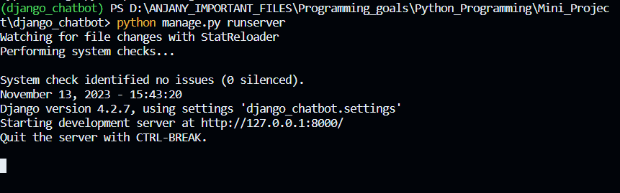

An employee PC pinging the server via private IP

* 1. **HTTPS Check**

The server access was checked with HTTPS by using a browser:

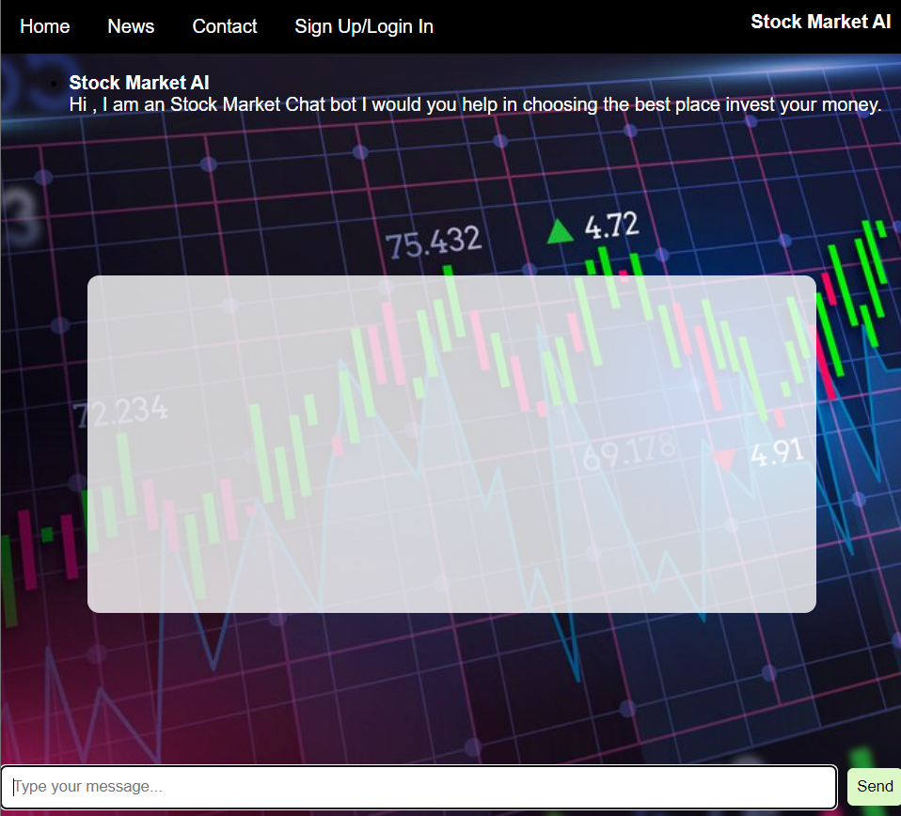

* 1. The Front-End Code :

File name: chatbot.html

Language used(Html , css , Java-Script)

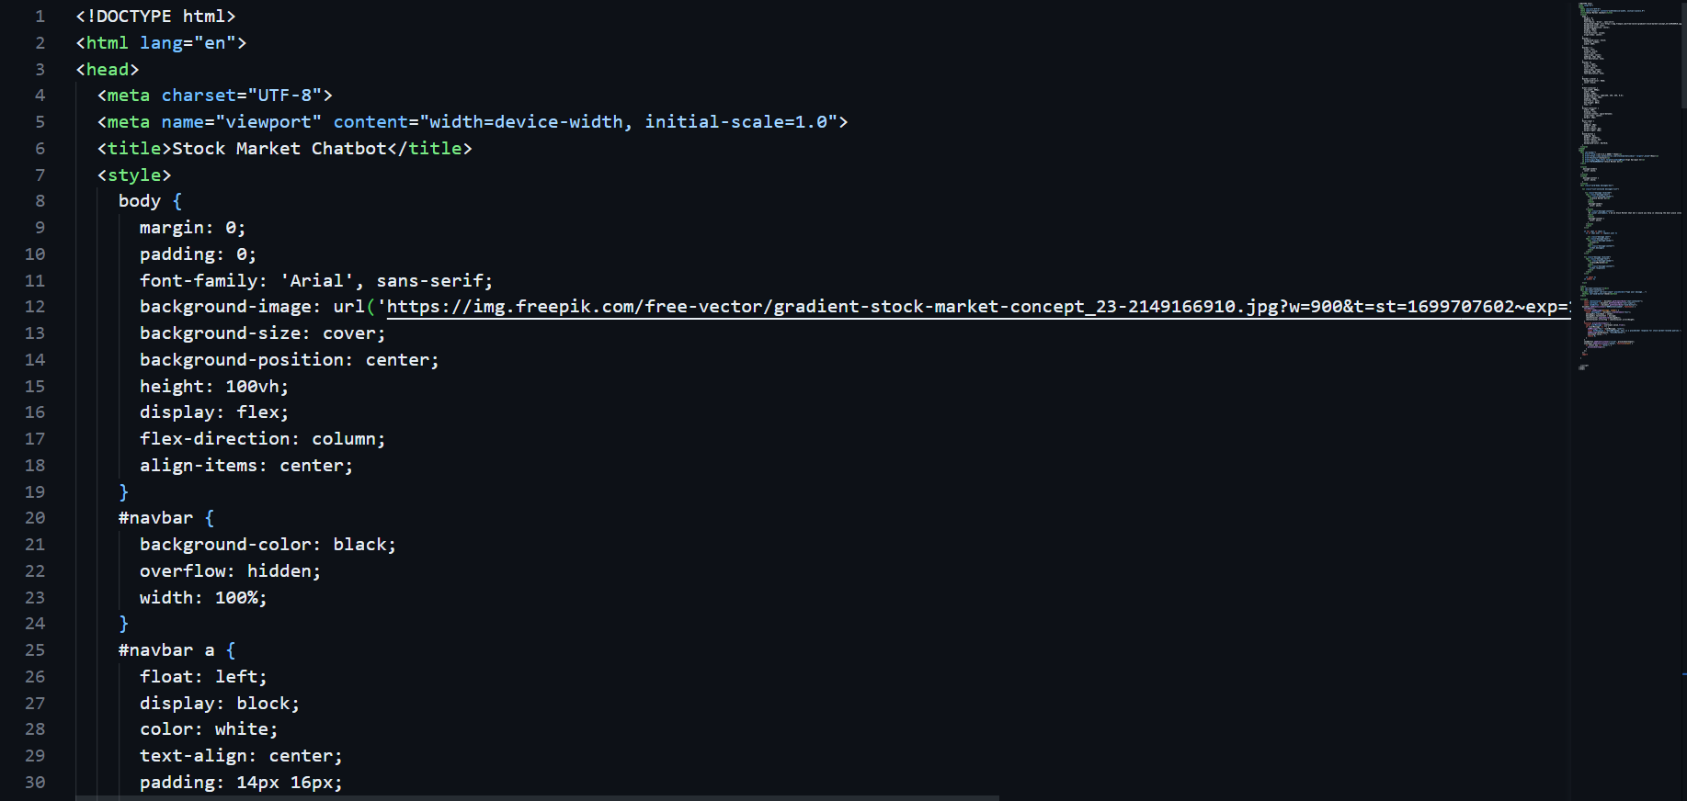

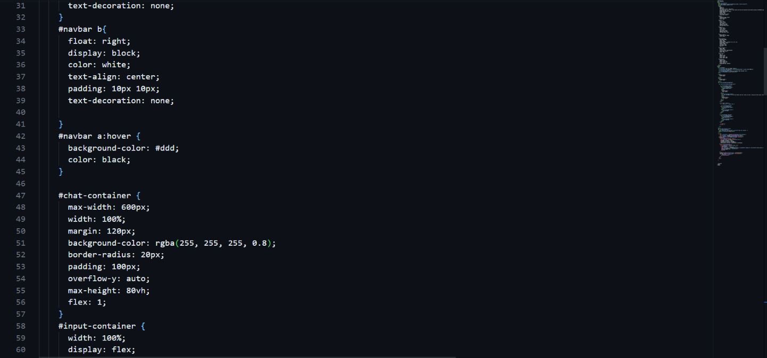

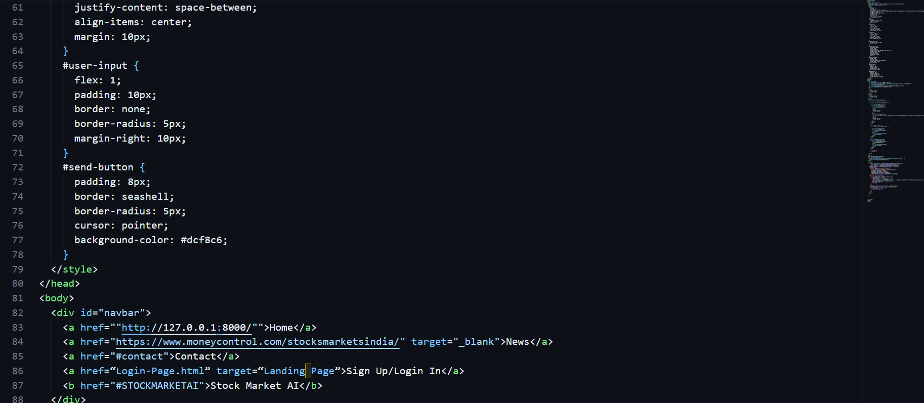

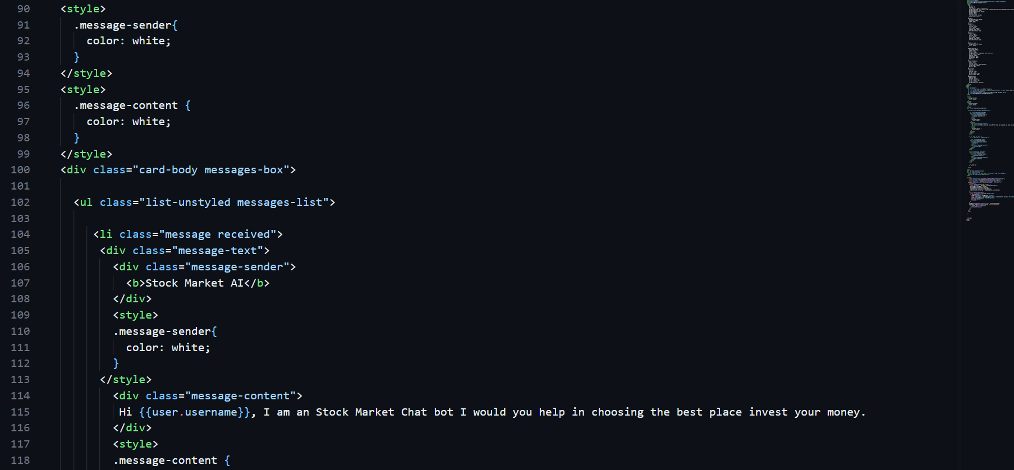

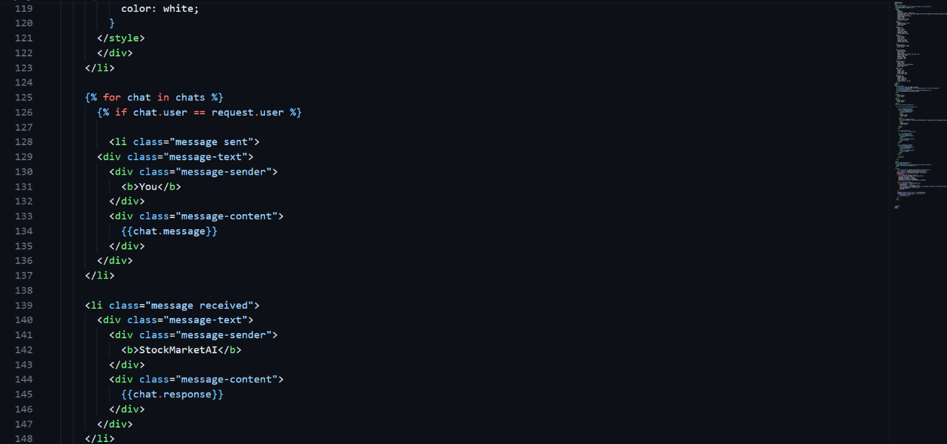

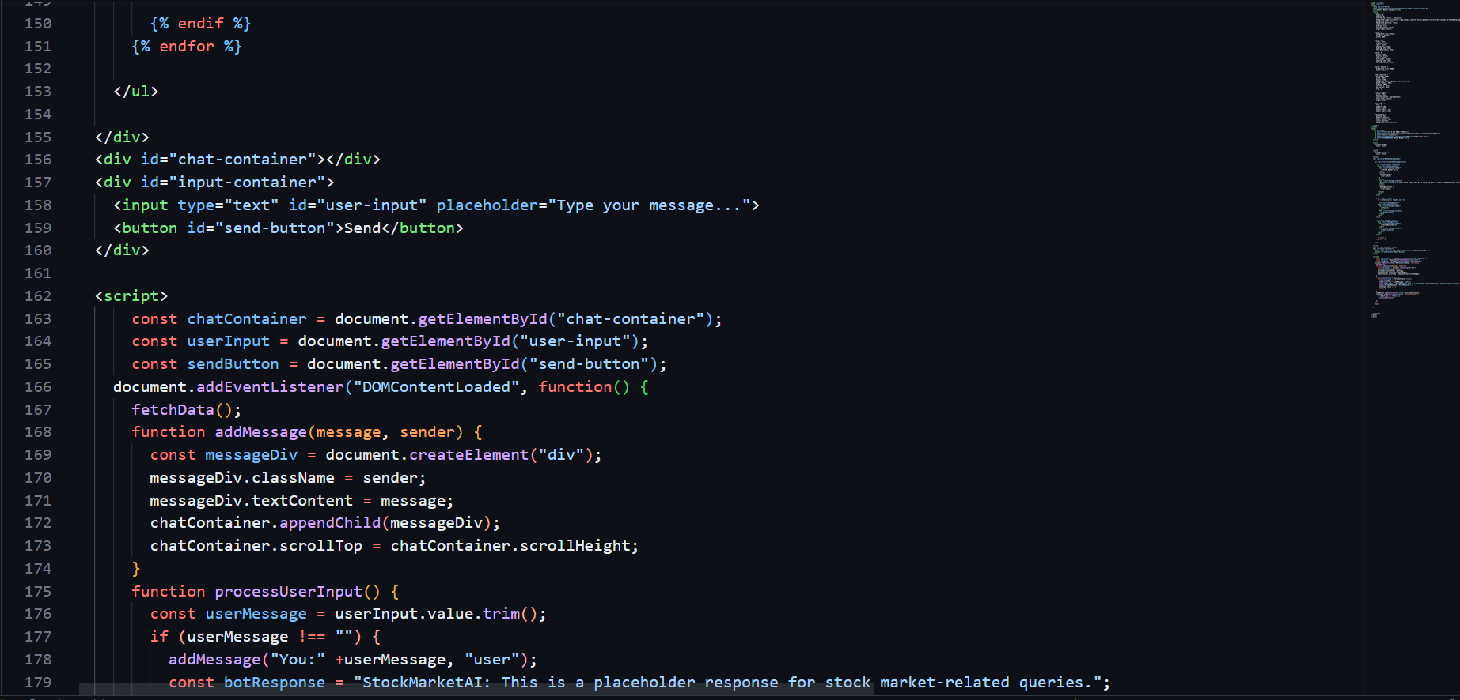

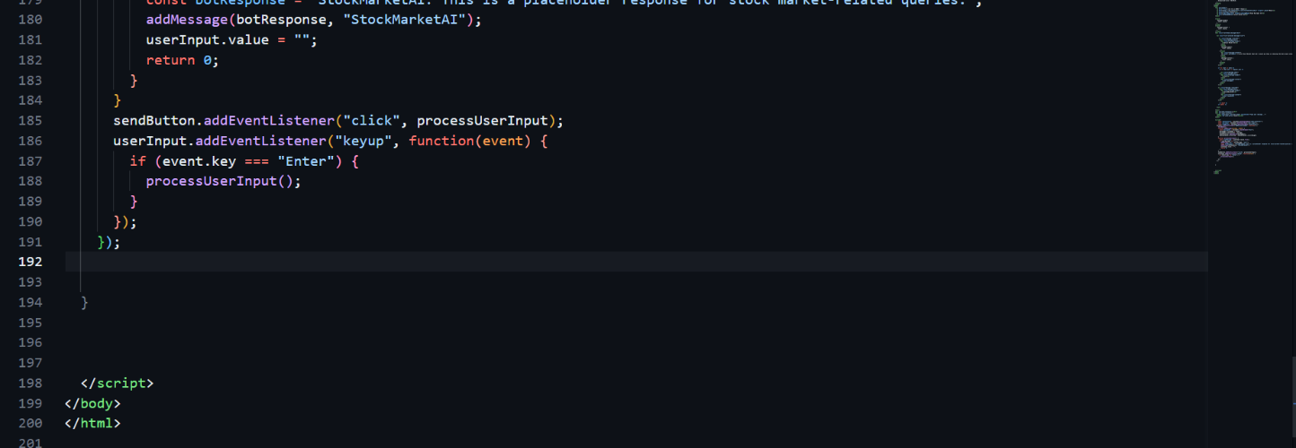

1. **CONCLUSION**

**d. The Back-End Coding:**

**File name: palm_responses.py**

**Language used(Python : The Libaries involved Django , PaLm-API)**

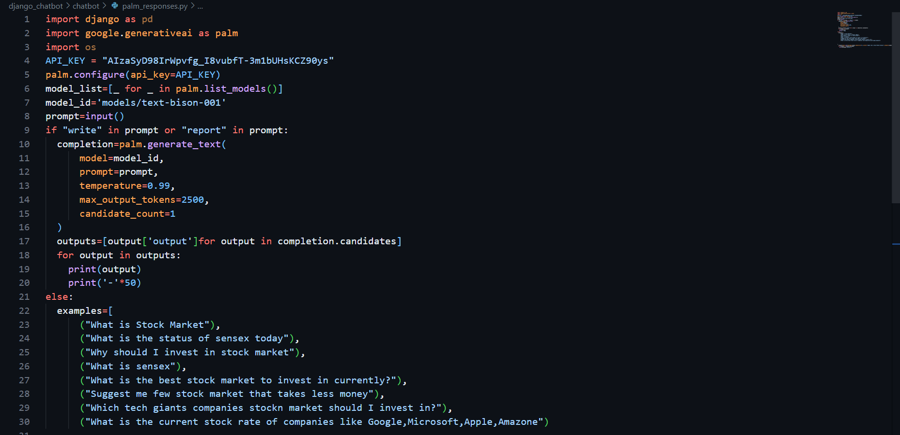

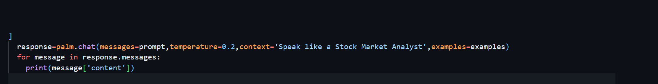

**REFERENCES**